# CS 255 System Design Document Template

## UML Diagrams

### UML Use Case Diagram

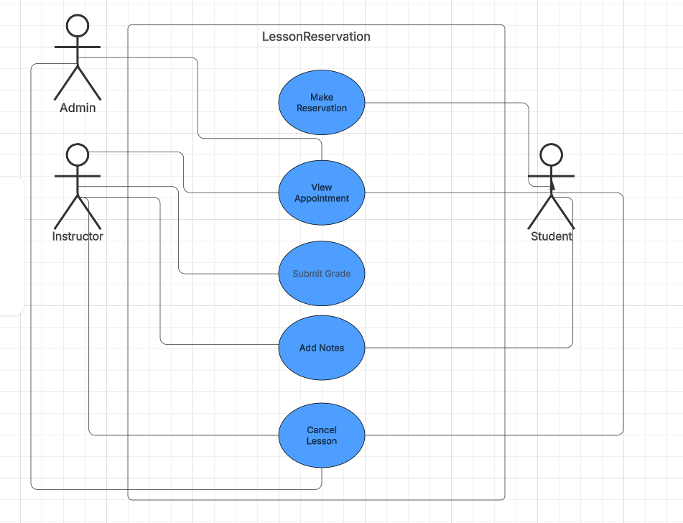

### UML Activity Diagrams

### UML Sequence Diagram

### UML Class Diagram

## Technical Requirements

*[Based on the diagrams you have created, describe the technical requirements of your system. These requirements should address the required hardware, software, tools, and infrastructure necessary for your system design.]*

*In order to run this system with a web-based portal we will need:*

* *Linux server to host our backend databases (done through 3rd party service like AWS)*
* *Ability to produce reports as .csv files*
* *Backend should have an uptime of 99% (1% used for maintenance)*